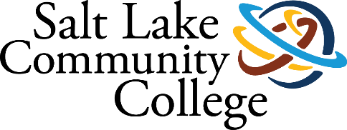 | STUDENT CENTER OPERATIONS
2019-2020 ANNUAL ASSESSMENT
SUMMARY OF RESULTS

Project (Assessment) Title:

Student Center Events and Reservations; Optimizing Client Experience

College-wide Strategic Goal:

1. Secure Institutional sustainability and capacity

2. Increase student completion

Assessment Overview:

The objective for this assessment is to seek feedback from the main clients of the Student Center and devise a plan to enhance and optimize customer experience during various stages of the event management.

Methodology (Plan/Method):

The original chosen methodology for conducting this assessment was to form a focus group consisting of the main clients of the Student Center. Due to the constraints brought about by of COVID-19, we decided to utilize a Google Forms format to conduct our assessment.

Timeline:

October-November: planning document due by November 15, December-February: organize focus group, form questions and meet with assessment committee at VP extended staff meeting on February 14; March-April: meet with focus group, collect and analyze data to develop general themes, May-June: Develop action plan, submit assessment report by July 1st.

Results/Findings:

Based on the information provided by our clients the following were identified as potential areas that could use improvement:
- Availability of event staff before/during events
- Rooms unlocked by/before start time.
- Double bookings/scheduling conflicts
- Event staff availability for early morning events

Action Plan (Use of Results/Improvements/Call to Action):

- Event staff will be more readily available before/during events to help with audio/visual setup and assistance especially for larger events. STC event staff will also help with training of frequent users on the use of A/V equipment.
- Event staff will make certain that all meeting rooms are unlocked and ready for use before the meeting start time.
- STC will look into the “double booking” issue and find out if there’s a bug in EMS that allows this to happen.
- STC will look into providing STC event staff with a cell phone or ask staff to forward our main office number to their personal cell phones. This should address a concern brought up regarding a contact for early morning events.
- STC will work with staff in IT and Classroom Technology to improve the user experience of the Oak Room A/V. One of these improvements would be to purchase a new podium with built in power, HDMI, and VGA inputs for convenience.
- We will explore programming conference room doors to unlock at the same time as the building to see if that is a good way to ensure access to our conference rooms.
- We will encourage folks to hold events on the second floor blocks.

Other Notes:
Thanks for everyone’s participation and involvement!

